Thrush and Hoof Care
Drs. Foster & Smith Educational Staff
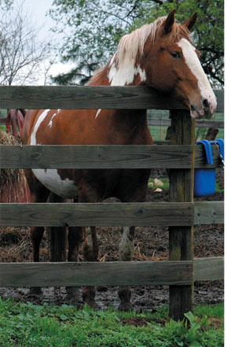 | 
 | As a horse enthusiast, you are probably familiar with a hoof condition called "thrush." Thrush is a degenerative condition of the frog of the hoof. Thrush appears as a foul-smelling, black, clay-like material in the area surrounding the frog. Thrush is caused by infections with anaerobic bacteria (bacteria that thrive when no oxygen is present). They eat away at the tissues of the frog, leaving a blackish ooze on the surface.
Just as in prevention of any other infection, a clean, dry environment is a must. A frog consistently packed with manure, mud, or moist bedding can be a hotbed for a nasty thrush infection.
Although standing in urine and manure-saturated mud doesn't cause thrush itself, these conditions can be a precursor to the development of thrush. Some other conditions that may predispose a horse to a dangerous thrush infection include:
A horse with overgrown or contracted hooves
A horse who does not get adequate exercise
A horse with a hoof problem not related to thrush - thrush may develop in the affected hoof
Handling thrush takes a three-pronged approach: eliminate the bacteria that cause thrush, manage the horse's environment, and maintain healthy hooves. Consult with your farrier and veterinarian to determine the best program for your horse.
Eliminate Thrush-causing Bacteria
Ridding your thrush-infected horse of the organism includes getting any treatment into the nooks and crannies where the bacteria that causes thrush thrives. Here is our recommended step-by-step approach:
Use a hoof pick with a twist of cotton around it to make a homemade swab.
Soak the cotton end of the swab in thrush treatment solution, such as Thrush Buster, which many horse owners use for this condition.
Use the swab to put treatment solution down the sides of the frog. Make sure you don't miss any nooks or crannies, where thrush likes to hide.
Use the swab to get the solution on the surface of the frog, including the cleft or any indented areas.
The swab will become darker as you work, so you may have to replace the cotton until it no longer picks up debris from the hoof.
For horses that seem to contract thrush no matter how stringent the management strategy, control of the infection may require daily treatment with a commercial thrush product. If thrush goes untreated, a more serious foot infection can ensue.
Eliminate the Environmental Risk Factors of Thrush
Keep your horse's environment clean. For instance, you can use the Future Fork to muck out stalls regularly. Use an all-surface wash like EQ Solutions for cleaning stubborn grime and to help prevent dirt from sticking to stall surfaces. Keep a Spray Bottle filled with horse-safe cleaning solution on hand for day-to-day cleaning. Use barn lime underneath your horse's bedding to keep moisture from his stall environment. Don't forget to keep your horse's outside environment (paddock or pasture) clean and dry.
Keep Hooves Healthy
To help prevent a thrush infection:
Clean hooves regularly, and use a drying agent or hoof conditioner, if necessary.
Increase your horse's exercise time.
Help keep hooves healthy with an oral hoof supplement.
Make sure your horse's hooves are trimmed regularly.
A horse's hooves are the foundation of a healthy horse. A thrush infection can be uncomfortable and unpleasant. With the right management program and tools, thrush can be prevented.

